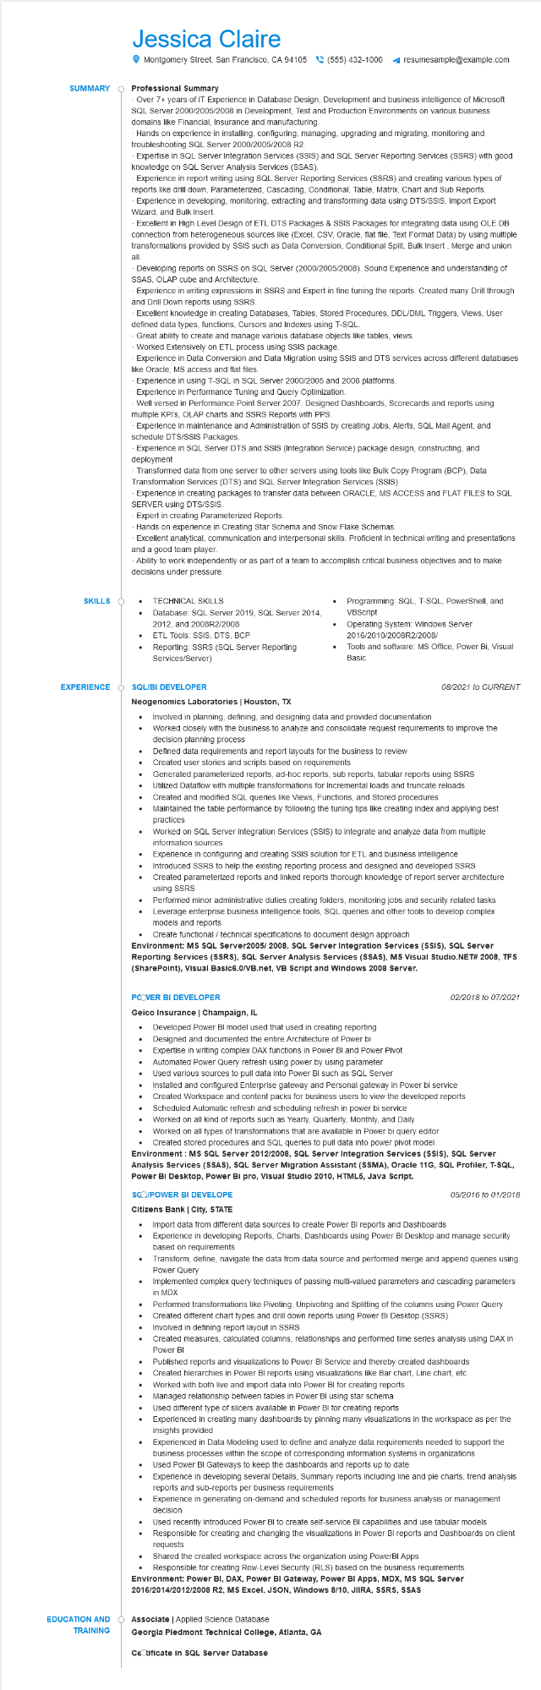
SUMMARY
Jessica Claire
Montgomery Street, San Francisco, CA 94105 (555) 432-1000
Professional Summary
resumesample@example.com
Over 7+ years of IT Experience in Database Design, Development and business intelligence of Microsoft SQL Server 2000/2005/2008 in Development, Test and Production Environments on various business domains like Financial, Insurance and manufacturing.
Hands on experience in installing, configuring, managing, upgrading and migrating, monitoring and troubleshooting SQL Server 2000/2005/2008 R2.
Expertise in SQL Server Integration Services (SSIS) and SQL Server Reporting Services (SSRS) with good knowledge on SQL Server Analysis Services (SSAS).
Experience in report writing using SQL Server Reporting Services (SSRS) and creating various types of reports like drill down, Parameterized, Cascading, Conditional, Table, Matrix, Chart and Sub Reports. Experience in developing, monitoring, extracting and transforming data using DTS/SSIS, Import Export Wizard, and Bulk Insert.
Excellent in High Level Design of ETL DTS Packages & SSIS Packages for integrating data using OLE DB connection from heterogeneous sources like (Excel, CSV, Oracle, flat file, Text Format Data) by using multiple transformations provided by SSIS such as Data Conversion, Conditional Split, Bulk Insert, Merge and union
all.
Developing reports on SSRS on SQL Server (2000/2005/2008). Sound Experience and understanding of SSAS, OLAP cube and Architecture.
Experience in writing expressions in SSRS and Expert in fine tuning the reports. Created many Drill through and Drill Down reports using SSRS.
Excellent knowledge in creating Databases, Tables, Stored Procedures, DDL/DML Triggers, Views, User defined data types, functions, Cursors and Indexes using T-SQL.
Great ability to create and manage various database objects like tables, views.
Worked Extensively on ETL process using SSIS package.
Experience in Data Conversion and Data Migration using SSIS and DTS services across different databases like Oracle, MS access and flat files.
Experience in using T-SQL in SQL Server 2000/2005 and 2008 platforms.
Experience in Performance Tuning and Query Optimization.
Well versed in Performance Point Server 2007. Designed Dashboards, Scorecards and reports using multiple KPI's, OLAP charts and SSRS Reports with PPS.
Experience in maintenance and Administration of SSIS by creating Jobs, Alerts, SQL Mail Agent, and schedule DTS/SSIS Packages.
Experience in SQL Server DTS and SSIS (Integration Service) package design, constructing, and deployment
Transformed data from one server to other servers using tools like Bulk Copy Program (BCP), Data Transformation Services (DTS) and SQL Server Integration Services (SSIS)
Experience in creating packages to transfer data between ORACLE, MS ACCESS and FLAT FILES to SQL SERVER using DTS/SSIS.
Expert in creating Parameterized Reports.
Hands on experience in Creating Star Schema and Snow Flake Schemas.
Excellent analytical, communication and interpersonal skills. Proficient in technical writing and presentations and a good team player.
Ability to work independently or as part of a team to accomplish critical business objectives and to make decisions under pressure.
SKILLS
• TECHNICAL SKILLS
Database: SQL Server 2019, SQL Server 2014,
2012, and 2008R2/2008
• ETL Tools: SSIS, DTS, BCP
Reporting: SSRS (SQL Server Reporting Services/Server)
Programming: SQL, T-SQL, PowerShell, and VBScript
Operating System: Windows Server 2016/2010/2008R2/2008/
Tools and software: MS Office, Power Bi, Visual Basic
EXPERIENCE
SQL/BI DEVELOPER
08/2021 to CURRENT
Neogenomics Laboratories | Houston, TX
•
Involved in planning, defining, and designing data and provided documentation
Worked closely with the business to analyze and consolidate request requirements to improve the decision planning process
Defined data requirements and report layouts for the business to review
• Created user stories and scripts based on requirements
Generated parameterized reports, ad-hoc reports, sub reports, tabular reports using SSRS
Utilized Dataflow with multiple transformations for Incremental loads and truncate reloads
Created and modified SQL queries like Views, Functions, and Stored procedures
•
Maintained the table performance by following the tuning tips like creating index and applying best practices
Worked on SQL Server Integration Services (SSIS) to integrate and analyze data from multiple information sources
Experience in configuring and creating SSIS solution for ETL and business intelligence Introduced SSRS to help the existing reporting process and designed and developed SSRS
Created parameterized reports and linked reports thorough knowledge of report server architecture using SSRS
Performed minor administrative duties creating folders, monitoring jobs and security related tasks Leverage enterprise business intelligence tools, SQL queries and other tools to develop complex models and reports
• Create functional/technical specifications to document design approach
Environment: MS SQL Server2005/ 2008, SQL Server Integration Services (SSIS), SQL Server Reporting Services (SSRS), SQL Server Analysis Services (SSAS), MS Visual Studio.NET# 2008, TFS (SharePoint), Visual Basic6.0/VB.net, VB Script and Windows 2008 Server.
PCOVER BI DEVELOPER
Geico Insurance | Champaign, IL
· Developed Power BI model used that used in creating reporting
Designed and documented the entire Architecture of Power bi
·
·
Expertise in writing complex DAX functions in Power BI and Power Pivot Automated Power Query refresh using power by using parameter
Used various sources to pull data into Power BI such as SQL Server
02/2018 to 07/2021
• Installed and configured Enterprise gateway and Personal gateway in Power bi service
• Created Workspace and content packs for business users to view the developed reports Scheduled Automatic refresh and scheduling refresh in power bi service
Worked on all kind of reports such as Yearly, Quarterly, Monthly, and Daily
Worked on all types of transformations that are available in Power bi query editor
Created stored procedures and SQL queries to pull data into power pivot model
Environment: MS SQL Server 2012/2008, SQL Server Integration Services (SSIS), SQL Server Analysis Services (SSAS), SQL Server Migration Assistant (SSMA), Oracle 11G, SQL Profiler, T-SQL, Power BI Desktop, Power Bi pro, Visual Studio 2010, HTML5, Java Script.
SCO/POWER BI DEVELOPE
05/2016 to 01/2018
Citizens Bank | City, STATE
• Import data from different data sources to create Power BI reports and Dashboards Experience in developing Reports, Charts, Dashboards using Power BI Desktop and manage security based on requirements
Transform, define, navigate the data from data source and performed merge and append queries using Power Query
Implemented complex query techniques of passing multi-valued parameters and cascading parameters in MDX
Performed transformations like Pivoting, Unpivoting and Splitting of the columns using Power Query Created different chart types and drill down reports using Power Bi Desktop (SSRS) Involved in defining report layout in SSRS
•
Created measures, calculated columns, relationships and performed time series analysis using DAX in Power BI
Published reports and visualizations to Power BI Service and thereby created dashboards Created hierarchies in Power BI reports using visualizations like Bar chart, Line chart, etc
Worked with both live and import data into Power BI for creating reports
Managed relationship between tables in Power BI using star schema
Used different type of slicers available in Power BI for creating reports
Experienced in creating many dashboards by pinning many visualizations in the workspace as per the insights provided
•
Experienced in Data Modeling used to define and analyze data requirements needed to support the business processes within the scope of corresponding information systems in organizations Used Power BI Gateways to keep the dashboards and reports up to date
•
Experience in developing several Details, Summary reports including line and pie charts, trend analysis reports and sub-reports per business requirements
Experience in generating on-demand and scheduled reports for business analysis or management decision
Used recently introduced Power BI to create self-service BI capabilities and use tabular models Responsible for creating and changing the visualizations in Power BI reports and Dashboards on client
requests
Shared the created workspace across the organization using PowerBI Apps
Responsible for creating Row-Level Security (RLS) based on the business requirements Environment: Power BI, DAX, Power BI Gateway, Power BI Apps, MDX, MS SQL Server 2016/2014/2012/2008 R2, MS Excel, JSON, Windows 8/10, JIIRA, SSRS, SSAS
EDUCATION AND
Associate | Applied Science Database
TRAINING
Georgia Piedmont Technical College, Atlanta, GA
Cetificate in SQL Server Database

